**SQL Exercise 2**

1. Display all the Supplier names with the initial letter capital. A screen shot of a computer

   AI-generated content may be incorrect.
2. Display all the Supplier names in upper case.

1. Display all the Supplier names in lower case.

4. Display all the Supplier names padded to 25 characters, with spaces on the left.

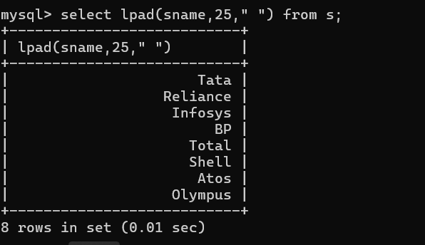

5.Display all the Supplier names (with ‘ta’ replaced by ‘ro’). HINT: REPLACE.

6. Implement the above command such that ‘l’ is replaced with ‘r’ and ‘a’ is replaced with ‘o’.

7. Display the Supplier names and the lengths of the names.

8. Use the soundex function to search for a supplier by the name of ‘BLOKE’.

9. Display the Supplier name and the status (as Ten, Twenty, Thirty, etc.).

10. Display the current day (e.g. Thursday).